Project Title: A Gesture-based Tool for Sterile Browsing of Radiology Images Project Design Phase-I - Solution Fit Template

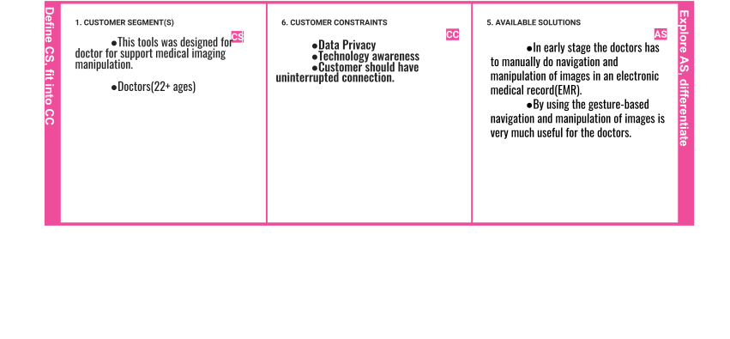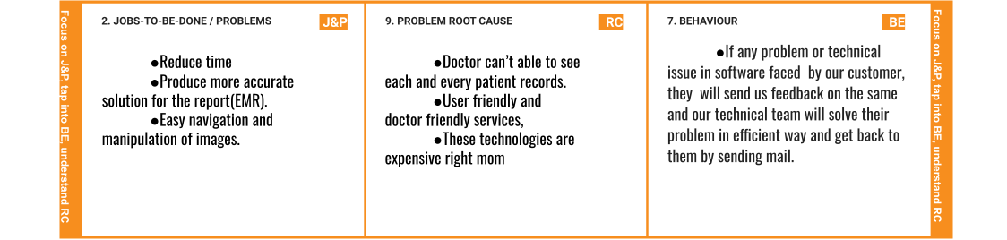

Team ID: **PNT2022TMID17537**

|  |  |  |  |  |
| --- | --- | --- | --- | --- |
|  | 1. **TRIGGERS TR**    * The time-efficient and easy browsing trigger the customers to switch to this technology. | 1. **YOUR SOLUTION SL**    * When this kind of software is launched worldwide this will be very much useful for doctors.      + It will make work easier and faster.      + This gesture-based technology is mainly based on hand signs in video frames and recognizes the images and performs a corresponding action. | **8. CHANNELS of BEHAVIOUR CH**   * ONLINE:   Extract channels from behsvior block.   * OFFLINE:   Extract channels from behavior block and is used for customer’s deployment. |  |
| 1. **EMOTIONS: BEFORE / AFTER EM**    * Sometimes doctors have to be there with the emotional situations of patients, which sometimes make doctor disturbed.      + But nowadays doctor uses gesture tool to save their work. |